on Metcalfe Street
When: Tuesday, October 30, 2018 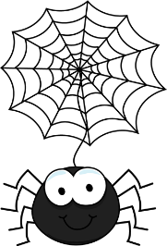
Time: 5:00pm – 7:30pm

Parent and/or Guardian(s),
In order to make this event happen, we need your help! Please send 2 bags of individually wrapped candy to your child’s class by Friday, October 26, 2018.

There will be a Spooky House and Trunk or Treat hosted by Metcalfe P.T.A.

